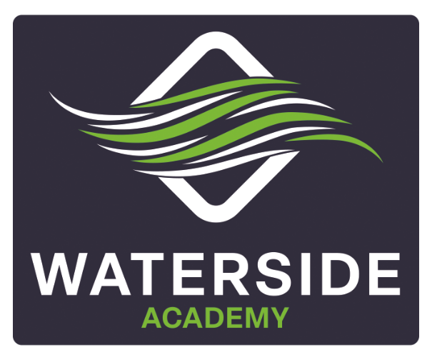

PRIVACY NOTICE - PUPILS
Policy Details
Frequency of review: | Annual
Lead member of staff: | Elaine Oliver
Last reviewed: | September 2026
Next Review Date: | September 2027

You have a legal right to be informed about how our school uses any personal information that we hold about you. To comply with this, we provide a ‘privacy notice’ to you where we are processing your personal data.
This privacy notice explains how we collect, store and use personal data about you.
We, Impact, are the ‘data controller’ for the purposes of data protection law.
Our Data Protection Officer is Judicium Education (see ‘Contact us’ below).

The personal data we hold
We hold some personal information about you to make sure we can help you learn and look after you at school.
For the same reasons, we get information about you from some other places too – like other schools, the local council and the government.
This information includes:
- Your contact details
- Your test results
- Your attendance records
- Your characteristics, like your ethnic background or any special educational needs
- Any medical conditions you have
- Details of any behaviour issues or exclusions
- Photographs
- CCTV images

Why we use this data
We use this data to help run the school, including to:
- Get in touch with you and your parents when we need to
- Check how you’re doing in exams and work out whether you or your teachers need any extra help
- Track how well the school as a whole is performing
- Look after your wellbeing

Our legal basis for using this data
We will only collect and use your information when the law allows us to. Most often, we will use your information where:
- We need to comply with the law
- We need to use it to carry out a task in the public interest (in order to provide you with an education)
Sometimes, we may also use your personal information where:
- You, or your parents/carers have given us permission to use it in a certain way
- We need to protect your interests (or someone else’s interest)
Where we have got permission to use your data, you or your parents/carers may withdraw this at any time. We will make this clear when we ask for permission and explain how to go about withdrawing consent.
Some of the reasons listed above for collecting and using your information overlap, and there may be several grounds which mean we can use your data.

Collecting this information
While in most cases you, or your parents/carers, must provide the personal information we need to collect, there are some occasions when you can choose whether or not to provide the data.
We will always tell you if it’s optional. If you must provide the data, we will explain what might happen if you don’t.

How we store this data
We will keep personal information about you while you are a pupil at our school. We may also keep it after you have left the school, where we are required to by law.
We have a records management policy which sets out how long we must keep information about pupils. A copy is available from the school office.

Data sharing
We do not share personal information about you with anyone outside the school without permission from you or your parents/carers, unless the law and our policies allow us to do so.
Where it is legally required, or necessary for another reason allowed under data protection law, we may share personal information about you with:
- Our local authority, central and local government – to meet our legal duties to share certain information, such as concerns about pupils’ safety and exclusions
- The Department for Education (a government department) – to meet our legal duties to share certain information, such as school census data
- Your family and representatives – to meet our legal duties to share certain information, such as concerns about pupils’ safety and welfare
- Educators and examining bodies – to meet our legal duties to share certain information, such as assessment
- Our regulator (the organisation or “watchdog” that supervises us), Ofsted – to meet our legal duties to share certain information, such as assessment and school census data
- Suppliers and service providers – so that they can provide the services we have contracted them for
- Survey and research organisations – so that they can provide the services we have contracted them for
- Health authorities – to meet our legal duties to share certain information, such as concerns about pupils’ safety and welfare
- Health and social welfare organisations – to meet our legal duties to share certain information, such as concerns about pupils’ safety and welfare
- Professional advisers and consultants – so that they can provide the services we have contracted them for
- Charities and voluntary organisations – so that they can provide the services we have contracted them for
- Police forces, courts, tribunals – to meet our legal duties to share certain information, such as concerns about pupils’ safety, exclusions and welfare
- Professional bodies – so that they can provide the services we have contracted them for

National Pupil Database
We are required to provide information about you to the Department for Education (a government department) as part of data collections such as the school census.
Some of this information is then stored in the National Pupil Database, which is managed by the Department for Education and provides evidence on how schools are performing. This, in turn, supports research.
The database is held electronically so it can easily be turned into statistics. The information it holds is collected securely from schools, local authorities, exam boards and others.
The Department for Education may share information from the database with other organisations which promote children’s education or wellbeing in England. These organisations must agree to strict terms and conditions about how they will use your data.
You can find more information about this on the Department for Education’s webpage on how it collects and shares research data.
You can also contact the Department for Education if you have any questions about the database.
Transferring data internationally
Where we share data with an organisation that is based outside the European Economic Area, we will protect your data by following data protection law.
Your rights
How to access personal information we hold about you
You can find out if we hold any personal information about you, and how we use it, by making a ‘subject access request’, as long as we judge that you can properly understand your rights and what they mean.
If we do hold information about you, we will:
- Give you a description of it
- Tell you why we are holding and using it, and how long we will keep it for
- Explain where we got it from, if not from you or your parents
- Tell you who it has been, or will be, shared with
- Let you know if we are using your data to make any automated decisions (decisions being taken by a computer or machine, rather than by a person)
- Give you a copy of the information
You may also ask us to send your personal information to another organisation electronically in certain circumstances.
If you want to make a request, please contact our data protection officer.
Your other rights over your data
You have other rights over how your personal data is used and kept safe, including the right to:
- Say that you don’t want it to be used if this would cause, or is causing, harm or distress
- Stop it being used to send you marketing materials
- Say that you don’t want it used to make automated decisions (decisions made by a computer or machine, rather than by a person)
- Have it corrected, deleted or destroyed if it is wrong, or restrict our use of it
- Claim compensation if the data protection rules are broken and this harms you in some way
Complaints
We take any complaints about how we collect and use your personal data very seriously, so please let us know if you think we’ve done something wrong.
You can make a complaint at any time by contacting our data protection officer.
You can also complain to the Information Commissioner’s Office in one of the following ways:
- Report a concern online at https://ico.org.uk/concerns/
- Call 0303 123 1113
- Or write to: Information Commissioner’s Office, Wycliffe House, Water Lane, Wilmslow, Cheshire, SK9 5AF

Contact us
If you have any questions, concerns or would like more information about anything mentioned in this privacy notice, please contact our data protection officer: Judicium Education
Email: support@judicium.com
Telephone: 0345 548 7000 (Option 1 then 1)
Website: judiciumeducation.co.uk

