Impact Pupil Referral Unit
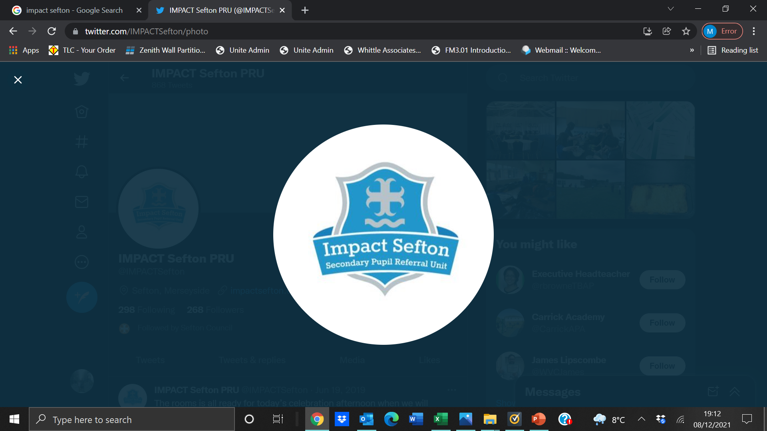

SERVICE LEVEL AGREEMENT

by and between

IMPACT Sefton

-AND-

(please insert school name)

FOR

Pupil Name:_________________________________________

Year Group:_________________________________________

Date:_________________________________________


This Agreement is made on the (date)

Between

(1) XXXXX School (“the Client”) for Pupil Name:

AND

(2) Impact Sefton (“the Provider”)
- ABOUT US

IMPACT Secondary Pupil Referral Unit is committed to inclusion. Part of the PRU’s strategic planning for improvement is to develop cultures, policies and practices that include all learners.

We aim to engender a sense of community and belonging, and to offer new opportunities to learners who may have experienced previous difficulties. This does not mean that we will treat all learners in the same way, but that we will respond to learners in ways which take account of their varied life experiences and needs.

We believe that educational inclusion is about equal opportunities for all learners, whatever their age, gender, ethnicity, difficulty, disability, attainment levels and background.

All learner at Impact will be equipped with the knowledge, skills, attitudes and behaviours to achieve their personal best.

We aim to provide an alternative curriculum of quality education and training for those pupils in Sefton for whom a vocational education provides the environment to promote learning.

We value each young person as an individual with individual needs and aspirations and strives to provide targeted, specific support in order to remove the barriers to engagement and learning.

- CLIENT GROUP

We provide education for young people aged 11-16 for whom mainstream education does not provide a suitable environment to motivate their learning. The group will include some young people who have presented extreme challenges to the schools resulting in exclusion.
The groups of young people targeted are those who:

- Have a pattern of disrupted education often as a result of truancy or anti-social behaviour which may have led to exclusion
- Have identified learning needs including emotional and behavioural difficulties
- Are in care of the Local Authority
- Suffer low levels of self-esteem and confidence often exhibited through an unwillingness to commit to mainstream provision
- Would benefit from a work orientated environment
- Have Special Educational Needs

- SUPPLY OF SERVICES

PROVIDER OBLIGATIONS:
The Provider shall:
- allocate sufficient resources to provide the Services in accordance with the terms of this Agreement;
- use reasonable skill care and diligence in the performance of the Services;
- provide the Services in accordance with good industry practice; and
- provide the Services in accordance with all applicable laws.
The Provider warrants:
- that it has sufficient number of qualified and skilled personnel to enable it to provide the Services during the Term of this Agreement;
- it will provide highly committed leaders, with ambitious goals, supported by a strong leadership team and staff;
- ensure highly consistent working practices throughout the school.
- its personnel are entitled to work in the United Kingdom and that where necessary its personnel have valid and current work permits in accordance with the provision of all current immigration legislation;
- it has carried out enhanced checks with the Disclosure and Barring Service against all personnel delivering the Services at IMPACT Sefton; and its personnel are fully conversant with its Safeguarding Policy.
- A probation or ‘Introductory period’ of two weeks will be attached to each placement. The introductory period will commence from the date of admission to Impact. Following the end of the introductory period, the supplier reserves the right to terminate the placement and the pupil will be returned to the client to continue their education by following the Discontinuance of Service Procedure set out in 3.12.
- In addition to the procedures set out in 3.12, the supplier will be required to provide a report to evidence the reason for termination and any and all service costs (including those outlined in 5.1 will be chargeable to the client in these instances.

CLIENT OBLIGATIONS:
The Client shall:
- promptly provide the Provider, on request, with all co-operation, information, assistance, materials and resources that the Provider may reasonably require prior to the admission of students and from time to time in connection with the supply of the Services and the performance of the Provider’s obligations under this Agreement;

- complete the Referral Form and submit associated files or documents
- requested on the referral form as provided by the Provider for each student that the Client wishes to place at MPS;
- follow the referral and admission process;
- attend any review meetings required by the Provider;
- provide all necessary access to data to enable the Provider to comply with its obligations under this Agreement; and
- ensure that all information which it provides to the Provider is accurate, adequate and complete.
The Client warrants:
- that all of the information provided in the Referral Form is true and accurate in all respects and that all information that will allow the Provider to properly assess whether they are able to offer a place at
- MPS commissioned programme to a student has been provided, including but not limited to any special educational needs, safeguarding and welfare issues.

4. COST OF SERVICE

Pre Exclusions Place | £70 per day
Out of Borough Place | £120 per day

Covered in the Cost of Service is;
- Mandatory education for the pupil
- Transport to and from the place of education to home address (within the Sefton Borough)
- Lunch if the pupil is eligible for free school meals

The supplier will follow the Local Authority travel guidance to provide the most suitable transport in the provider’s opinion.
Should the client deem the provided transport unsuitable, they can liaise with the provider to schedule another form of transport at additional cost to the client.

5.1 Additional Costs to Parents

Clients should be aware that parents will be advised of the following
The supplier operates a zero tolerance policy to vandalism and damage across the school. Parents will be charged by the school for any and all damage and vandalism where we have proof or witnesses. Costs for this will depend on the vandalism and damage sustained, however certain types of vandalism / damage have a set charge as detailed within the school’s Charges policy.

5. NEEDS ANALYSIS

The provision of the service may fundamentally change during the lifetime of this SLA in the light of developments within Impact, Local Authority guidelines, DfE or other such bodies initiatives.

6. QUALITY ASSURANCE

The education offered will be monitored regularly by the head teacher and her nominated representatives to ensure that performance standards are being met, and remedial action is taken, where appropriate. The provider and any subcontractors used in the delivery of education will be expected to adhere to the following:

- Ensure that competent and appropriately qualified and experience staff deliver appropriate courses.
- Provide a safe, healthy and supportive environment which meets the requirements of safeguarding regulations and all policies and procedures.
- Ensure pupils are following a structured qualification at an appropriate level
- Timely reporting of attendance of pupils and first day response procedures
- If requested by the client, provision of termly reports on pupil’s attendance, behaviour, conduct and achievement of agreed targets.

7. MONITORING ARRANGEMENTS

Student progress and wellbeing during their placement at Impact are monitored through timely progress reviews.

During a 12-week pre-exclusion placement progress reviews will be held at:
- 6 weeks: Mid-point review to address current progress and recommendations;
- 10 weeks: Re-integration review to plan a reintegration programme for the last two weeks of placement;
- 12 weeks: Placement review report to be sent to school with Individual pupil profile detailing assessments, counsellor input and recommendations to aid successful transition.

8. CONDITIONS OF AGREEMENT

Purpose of the Agreement
The client as detailed on the front cover of this document and Impact as the Supplier shall both abide by the terms and conditions set out in this agreement.

8.2 Length of the Agreement
Provision of the services shall commence from 1st September 2022 and conclude on 31st July 2023 and shall follow the term dates for the school within that time period.

8.3 Payment methods
Invoices will be raised in arrears at the end of each term. The invoice required at the end of the financial year may be raised earlier by the supplier. The invoice at the end of the academic year may be raised earlier if requested by the client to ensure payment is made prior to the end of term or to meet financial year requirements for academies.

Base costs per session are outlined in Section 5 of this document. Additional charges which may be levied are also detailed here

8.4 Breach of Agreement
Where either Party is in breach of this Agreement and the breach is capable of remedy, the non-defaulting Party shall, before taking any action that it is otherwise entitled to take by virtue of this Agreement, shall request a meeting with the other party. This Breach meeting will set out specify the steps that the defaulting party must take to the satisfaction of the non-defaulting Party in order to remedy the breach and the period during which the steps must be taken. The information agreed within this meeting will be written into a “Breach Notice”.
Where the non-defaulting party is satisfied that the defaulting party has not taken the required steps within the time period agreed in the Breach Notice, the non-defaulting Party may terminate this Agreement on a date of their choice following the date the time period stated in the Breach notice ceases.

8.5 Variations
The Client and the Supplier may agree to vary the service at any time during the term of the Agreement. Such variation shall be recorded in writing and signed by both parties.

Where there is a substantial change both parties will consider whether any financial adjustments shall be made in respect of the Fee(s).

8.6 Confidentiality
Neither party shall disclose to any other party any information in connection with the provision of the service nor any information contained in the agreement other than in compliance with the agreed information format specified in compliance with the provisions of the Data Protection Act 1998.

The parties acknowledge that any information obtained from or relating to the other or its business or affairs, its servants, agents or employees or Service Users is confidential information and as such, the parties acknowledge that such information will only be disclosed by one party to the other for the purposes of this agreement.

The exception is the Client’s duty as a Public Authority under the Freedom of Information Act 2000. As part of the duties of the Client under the Act, from Jan 1st 2005 they may be requested to disclose information that may relate to any information forming part of this Agreement. Before releasing any such information the Client will consult fully with the Provider as to the suitability/sensitivity of the request under the terms of the Act.

The parties will not disclose confidential information to any third party without the other party's written consent and where the confidential information relates to an individual pupil or the identity of such pupil without the prior written consent of that pupil’s parents or pupil (if over the age of 14) unless;

- It is in or comes into the public domain (except if this is as a result of a breach of either party of this Agreement).
- It is required to be disclosed by or to any Regulatory Body or Governmental Body.
- It is required to be disclosed by either Party to its professional advisers.
- Both Parties will collect and maintain information in accordance with Data Protection Legislation as it applies from time to time.

8.7 Records and Information - Legal Requirements
The supplier will maintain procedures for the keeping of records that comply with the statutory requirements. These records will include those required by the Care Standards Act 2000, the Children Act 1989 and the Children Act 1989 - Guidance and Regulations.

It is the responsibility of both parties to comply with all current statutory requirements in respect of record keeping.

8.8 Statutory Requirements
Both parties shall comply with all statutory requirements relating to the provision of the service.

8.9 Assignment and Subcontracting
The Supplier shall not transfer or assign this agreement. However, they may subcontract service provision. The supplier will remain fully responsible for the management of any subcontractor. Services delivered by any subcontractor will continue to be measured against this SLA.

8.10 Arbitration
A dispute, which the parties cannot resolve, will be referred to the Strategic Director, Children’s Services. Any decision shall be accepted as final to both parties.

8.11 Monitoring and Liaison
The parties to this agreement will be required to jointly implement and maintain a system for monitoring this agreement at the commencement. The head teacher and person detailed on the front of this document are the only two named individuals with whom this contract can be discussed unless the supplier is formally instructed otherwise. The head teacher of Impact will be assumed to be the Contract Manager for the Client.

8.12 Notice and Termination Of Agreement
8.12.1 This agreement will automatically terminate on 31st July in the year detailed on the front page of this SLA.

8.12.2 The Parties may agree in writing to terminate this Agreement and if the Parties so agree, they shall agree the date upon which that termination will take affect and any further terms upon which this Agreement, should be terminated.

8.12.3 The supplier may terminate this Agreement at any time, by serving notice in writing if not less than 28 days on the other party.

8.12.4 In the event of a termination in accordance with Clauses 3.11.1 or 3.11.3 the Client will continue to pay the Provider in accordance with the terms of this Agreement during the notice period.
8.12.5 The Parties may agree to terminate or the supplier may terminate an individual Service User placement, in which case the Parties will follow the Discontinuance of Service Procedure set out in 3.12.

8.12.6 The client may, should they wish to terminate this Agreement without further question upon providing 48 hours written notice to the Provider if the school is deemed to be placed into the Category of “Requires Improvement” following an Ofsted Inspection

8.13 Discontinuation of Service
Both the Client and Supplier shall seek to ensure that where the Service is discontinued to individual pupils, it is planned as an outcome of the ongoing review process, with an end date agreed in advance and recorded.

Where this is not possible the Service shall be discontinued to individual pupils within a reasonable period after consultation between the Client and the Supplier:

- If the introductory period has been unsuccessful.
- Where following a review of service or conclusion of time period in a Breach notice, it is apparent and agreed that;
  - the needs of the pupil have changed to a point where care is needed of a level the provider is unable to offer.
- the service offered is unsuitable for reasons other than those specified above.

Where it is not possible to discontinue the Service to a pupil within the specified period, the end date may be extended by mutual consent of the Supplier and Client.

8.14 Health and Safety
The Service Provider shall at all times comply with:

  - All relevant Health & Safety Acts, and Health and Safety Regulations approved by the Health and Safety Executive
  - Its own Health & Safety Policy and Procedures
  - Any Policies and Procedures of the Client

Health and Safety responsibilities extend to staff that undertake work on school premises. Training providers are therefore asked to ensure the well-being of all staff.
8.15 Disclosure
The Service Provider will ensure that all staff involved in the education of their pupils have a fully enhanced DBS check in line with Home Office guidance. All enhanced DBS checks to be subject to review at three-year intervals.

8.16 Equal Opportunities
The Provider will comply with the Race Relations and Equal Opportunities legislation and not discriminate against any person or organisation on the ground of race, gender, disability, sexual orientation, age, religion or belief, unemployment / employment or economic status.

8.17 Compliance with Safeguarding and other relevant procedures
The supplier shall at all times comply with all policies including but not restricted to the following, which can be found on the supplier’s website:
- their own Safeguarding policy and procedures approved by the governing body
- their own child protection policy and procedures.
- Their own behavior management policy.

8.18 Endorsement
The parties hereby agree to the terms and conditions as described in this agreement.
This Agreement shall be considered as an Agreement made in England
and subject to English Law.
The Parties do not intend any term of this Agreement to be enforceable by a third party and for the avoidance of doubt the provisions of the Contract (Rights of Third Parties) Act 1999 does not apply.

8.19 Flexibility
The nature and diversity of any provision may require a degree of flexibility in the delivery method due to individual support requirements, which may include one to one mentoring for pupils who have special educational needs. This will be agreed with the provider at the outset of an exercise, and will be kept under a continuous review thereafter until complete.

9. DEALING WITH COMPLAINTS
The supplier has and published a written complaints procedure on the school website to enable clients to make complaints about the supplier or the service they provide.

SIGNATORIES
SIGNED BY or on behalf of the parties:
The Client:
Name.................................................................................................

Signature…………………………………………………………………

Position……………………………………………………………………………..

Date…………………………………………………………………………………

Signed on behalf of …XXXX School……….(school/academy)

The Provider:

Name...............................................................................................

Signature...………………………………………………………………

Position……………………………………………………………………………..

Date…………………………………………………………………………………
Signed on behalf of Impact Sefton

